Press Release 6 August 2013
Leonora Carrington Retrospective at the Irish Museum of Modern Art
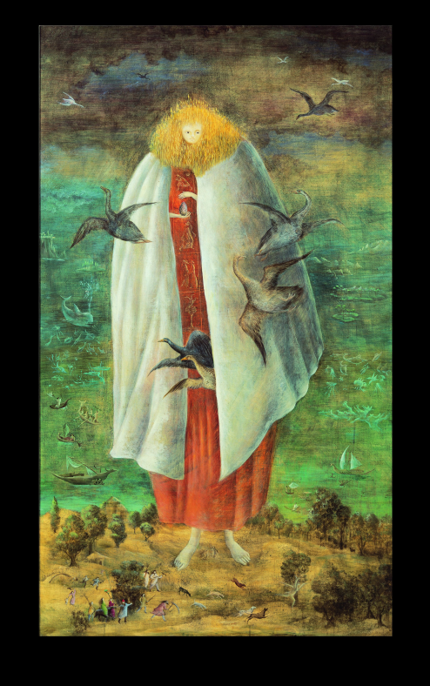
Leonora Carrington, The Giantess (The Guardian of the Egg), 1947 circa, Tempera on wood panel, 117 x 68 cm, Collection Miguel S. Escobedo, © Estate of Leonora Carrington / ARS
The first major retrospective in Ireland of the work of Surrealist painter Leonora Carrington opens to the public on Wednesday 18 September 2013 in the Garden Galleries (formerly the New Galleries) at the Irish Museum of Modern Art. The Celtic Surrealist is a timely rediscovery of one of the last Surrealist painters and her role in the Surrealist art movement. Carrington is known for her figurative dreamscapes filled with extraordinary and complex narratives informed by her rich interest in mythology, alchemy, fairy tales and the occult. This exhibition of some 30 paintings, six sculptures, four tapestries and 30 works on paper from the 1940s onwards, holds a particular focus on the imagery that enchanted her as a child and on the cultural influences of Mexico.
The Celtic Surrealist focuses in particular on the imagery that enchanted Carrington as a child and on the influence of Mexico on her later work. This exhibition explores her work thematically rather than chronologically, themes such as metamorphosis and transformation which are constant in her work. Carrington’s is a hybrid world full of strange and slightly disconcerting figures - creatures half-human-half-horse, elongated women, people changing into birds; transformations seen in works such as The Giantess (The Guardian of the Egg), c. 1947 or Edwardian Hunt Breakfast, 1956. Certain works refer directly to the history or folklore of Ireland while others highlight the influence of Mexican culture in her fantastic imagery. Writing has always been a creative activity of equal importance as painting to Carrington, an area which has not been explored to any great extent in an exhibition before, so here the paintings are supplemented with unpublished manuscripts and illustrations all offering a rich visual experience for the reader.
Commenting on the exhibition Seán Kissane, Curator: Exhibitions, IMMA, said; “Despite her prominence in Mexico and the USA, the work of Leonora Carrington is little-known in Ireland. Aside from a small sculpture recently donated to IMMA by the Mexican Government, no work is held in public collections in this country. She is not on any of the school or university curricula, and yet every study made of her work asserts the importance which her Irish background held for her and the construction of her myriad images – both in word and painting. We hope that this exhibition will offer the timely chance to make her astonishing work available to a wider audience, in Ireland and far beyond.”
Between 1937 and 1947, Carrington was most closely aligned to the Surrealist movement. The importance of her writing was recognised by the leader of the movement André Breton, who included her comic short-story The Debutante in his Anthology of Black Humour, 1940. Incidentally she was the only woman-writer included in that book which was both a mark of respect and an indication of the wider situation for creative women who were marginalised by their male peers. She was the archetype for a Surrealist artist: a writer, a painter, a sculptor, a weaver, a mother. During her incarceration in Spain, she experienced madness first-hand, an experience which her Surrealist brothers sought to recreate using mind-altering drugs. She was ‘Irish’ and equipped with the knowledge of that race’s fairy tales and myths which were central to the Surrealist ideal, as evidenced by André Breton’s Surrealist Map of the World, 1937.
Leonora Carrington (Lancashire 1917 – Ciudad de México 2011) was the daughter of a British father and an Irish mother from Moate, Co Westmeath. In 1936, when she was 19, she moved to London and Paris, where she became a central figure in the Surrealist movement later exhibiting with André Breton, Max Ernst and others. In 1940, following the internment of her lover Max Ernst, she suffered a mental breakdown after which she escaped from Lisbon to Mexico where she lived until her death in 2011 at the age of 94.
The Celtic Surrealist forms part of IMMA’s programme of painting exhibitions, which has included major exhibitions by Frida Kahlo and Diego Rivera and Georgia O’Keeffe.
The Celtic Surrealist is curated by Seán Kissane, Curator: Exhibitions, IMMA.
A fully-illustrated catalogue, published by IMMA and DAP, New York, accompanies the exhibition. It includes contributions from specialists Dawn Ades, Teresa Arcq, Giulia Ingarao, Seán Kissane, Alyce Mahon, the son of Carrington Gabriel Weisz, and an interview between the artist and Hans Ulrich Obrist.
Talks and Events
Prelude Talk | Teresa Arcq
Sunday 15 September, 2.00pm – 3.00pm, Lecture Room, IMMA
Surrealist Women Artists in Exile
As a prelude to the Leonora Carrington retrospective, Teresa Arcq (Adjunct Curator, Museo de Arte Moderno, Mexico City) introduces Leonora Carrington’s magical world of paintings and stories, and situates this in the broader cultural context surrounding the exile of other Surrealist women artists to Mexico and the USA.
Preview Seminar | Rediscovering Leonora Carrington
Tuesday 17 September, 1.00pm - 6.00pm, the Chapel, IMMA
Garden Galleries Open from 10.00am – 8.00pm
The enigmatic work of Leonora Carrington is informed by her rich interest in Celtic mythology, children’s literature, feminism, and the ethnographic study of religion, myth, and magic. Yet, until recent times, little is known of this last Surrealist artist and her significant contribution to the Surrealist cultural movement. This seminar features presentations by leading scholars on Carrington’s work, who will discuss the artist’s personal and creative connections to prominent Surrealist circles in Europe and Mexico, explored through a range of critical contexts that are informing international reappraisal of Carrington’s work.
Invited speakers include Seán Kissane (Curator, Exhibitions, IMMA), Giulia Ingarao (Art Curator and Historian, Accademia di Belle Arti di Palermo) Teresa Arcq (Adjunct Curator, Museo de Arte Moderno, Mexico City), Dawn Ades (Professor of Art History and Theory, University of Essex, UK), Alyce Mahon (Senior Lecturer in History 20th Century Art, University of Cambridge), Susan Aberth (Associate Professor of Art History, Bard College, NY) and Chairperson Roisin Kennedy (Lecturer, School of Art History & Cultural Policy, UCD). The official exhibition launch and wine reception follow this event.
Culture Night Talk | Seán Kissane
Friday 20 September, 7.00pm, Garden Galleries, IMMA
Curator of the exhibition Seán Kissane (Curator, Exhibitions, IMMA) presents a gallery talk on some of his most fond works selected for this exhibition.
In Discussion | Women, Art and Society
Thursday 17 October, 5.30pm - 7.00pm, Lecture Room, IMMA
In conjunction with Leonora Carrington The Celtic Surrealist and Eileen Gray Architect Designer Painter this discussion invites artists, curators and academics to re-examine feminist art history in addressing closely related issues of ethnicity, class, labour, and sexuality in recent developments of contemporary art practice. Speakers explore the turn towards autobiography in women’s art and consider issues of the personal versus the political in reviewing similarities and differences for women artists working today and the seminal work of feminist artists of the past.
Gallery Talk | Artist Responses
Wednesday 13 November, 1.00pm - 2.00pm, Garden Galleries, IMMA
Contemporary artists discuss Surrealist ideas and their eclectic interests in metamorphosis, humour, gastronomy, animal imagary and fairytale as a means to re-evaluate Carrington’s unorthodox relationship to traditional aesthetics.

Lecture | Luke Gibbons Wednesday 20 November, 5.30pm - 6.30pm, Lecture Room, IMMA Magical (Sur)realism: Ireland, Mexico
Luke Gibbons (Professor of Irish Literary and Cultural Studies, National University of Ireland, Maynooth) will discuss the affinities between vernacular modernism and folklore in Surrealism. Gibbons examines the links between Carrington’s Irish interests with the distinctive Mexican cast of her visual modernism, in relation to film and the 'spectral' in contemporary Irish culture.
What is Programme _?
Series 2 | Talks on Modern Art
What is Surrealism …? | Fiona Loughnane
Saturday 16 November, 12noon, the Lecture Room, IMMA
As part of the IMMA What is _? Programme, presenter Fiona Loughnane (writer, Lecturer, NCAD) gives an introduction on the history, theory and central figures of Surrealist art in the context of the exhibition.
Series 4 | Discussions on Theory
What is Psychoanalysis?
MA Art in the Contemporary World (NCAD) and IMMA
Saturday 18 January, 12noon, Lecture Room, IMMA
In collaboration with MA Art in the Contemporary World (NCAD), presenters Declan Long and Francis Halsall (Lecturers, AWC-NCAD) give an introduction on the theory of Psychoanalysis and its relationship to contemporary arts practice. This is followed by a panel discussion with selected speakers.
Booking is essential for all talks. For free tickets and a full programme of events please visit www.imma.ie/talksandlectures
The exhibition is kindly supported by Brian Ranalow of H&K International; the American Friends of the Arts in Ireland; Gallery Wendi Norris, San Francisco; Noriega & Escobedo, Mexico, Roy & Mary Cullen Collection, Texas; and the Embassy of Mexico in Ireland.
The exhibition is supported by THE IRISH TIMES.
The Celtic Surrealist continues until 26 January 2014. Admission is free.
Opening hours:
Tuesday – Saturday: 10.00am – 5.30pm
except Wednesday: 10.30am – 5.30pm
Sunday and Bank Holidays: 12noon – 5.30pm
Monday: Closed
Open late until 9.00pm on Culture Night, Friday 20 September
For further information and images please contact Monica Cullinane or Patrice Molloy at Tel: +353 1 612 9900, Email: press@imma.ie
6 August 2013

