The Process Room

West Wing, First Floor Galleries, Irish Museum of Modern Art

The function of the Process Room is to reveal the processes in the creation, exhibition and consideration of contemporary art, which are often hidden from the public. The Process Room facilitates access to the ongoing practice of artists currently on residence at IMMA. This programme is located in the studios adjacent to the main Museum building. Several studios are allocated to both national and international artists and the Process Room is used on a rotating basis to display a taste of what is ongoing in the studio environments.

Behailu Bezabih (Ethiopia)

Fast Moving
May 24th – June 5th 2005

At this stage in his career Behailu Bezabih is enjoying experimentation in his work. Spontaneity and eagerness to try are major themes in his practice. As a painter and teacher Behailu takes inspiration from life around him, a world of fast moving ideas, in response Behailu is direct with his canvases, applying his thoughts quickly and embracing what he perceives to be successful while also letting go of what appears to have failed. The various motives and subjects in his paintings are mostly from daily life. Behailu would like to work on both public and personal projects while on residency here in Ireland.

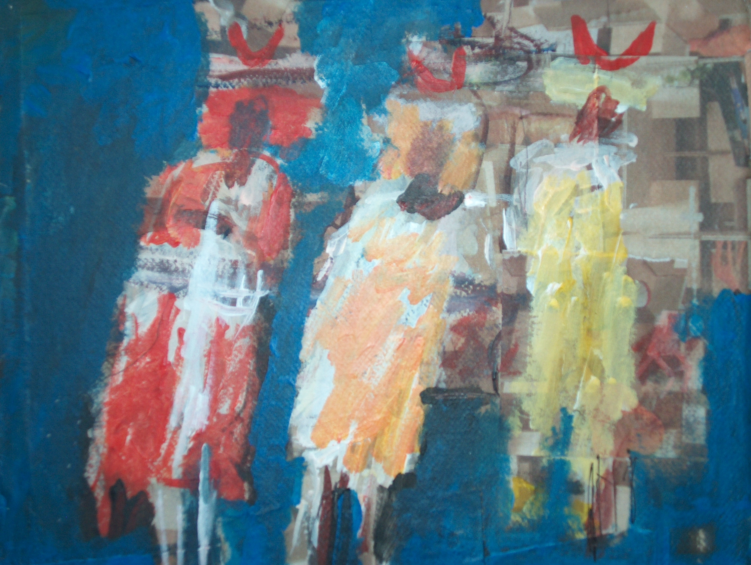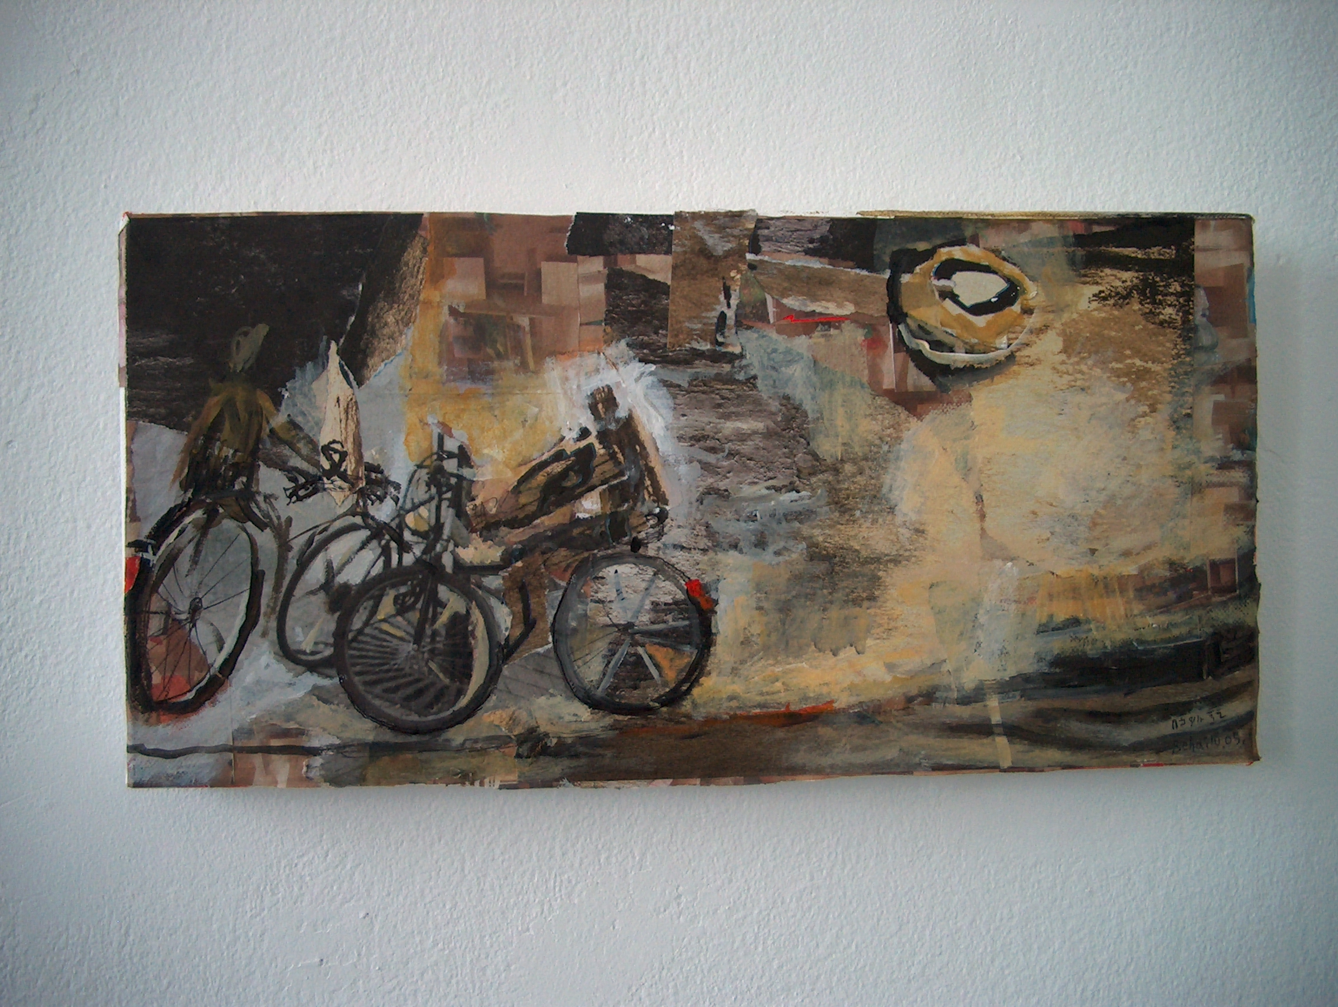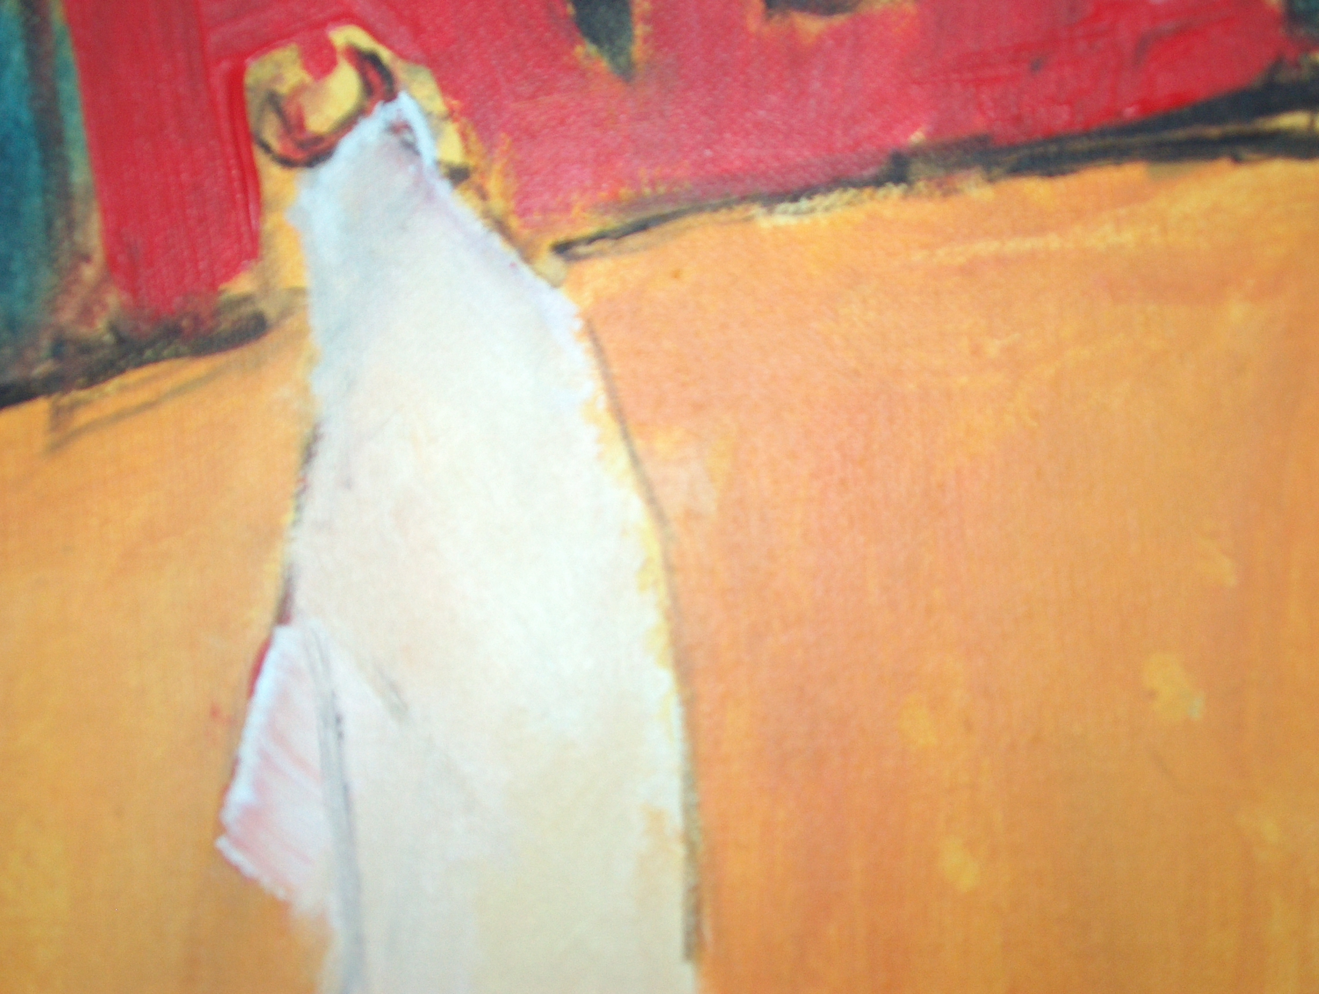

“I am painting directly onto canvases in the Process Room over the next two weeks, I don’t know what will come out but I am very excited. For me being in Ireland is a new experience and challenge, I aim to reflect this in my work. I will use techniques such as dripping, gluing, splattering and experimentation with compositions. I also aim to include some new print work in the show.”

Behailu Bezabih, 2005

For further information in relation to Behailu’s work please contact Janice Hough at 00353.1.6129905 or email janice.hough@imma.ie.
Further information on residencies at IMMA can be found at the website www.imma.ie

