Artists’ Residency Programme (ARP)

The Process Room
West Wing, First Floor Galleries, Irish Museum of Modern Art

The function of the Process Room is to reveal the processes in the creation, exhibition and consideration of contemporary art, which are often hidden from the public. The Process Room facilitates access to the ongoing practice of artists currently on residence at IMMA. This residency programme is located in the studios adjacent to the main Museum building where several studios are allocated to both national and international artists. The Process Room is used on a rotating basis and artists participating on ARP receive a two-week period to display their developing projects from their studio practice.

LIVING LENSES
Louise Bertelsen and Poshu Wang
Tuesday 10th July – Sunday 23rd July 2006

Living Lenses is a collaborative team comprised of Louise Bertelsen (Denmark) and Poshu Wang (USA). Their work is an on-going exploration of the world they live in, the world they live by, and the world they dream of. The media and methodology that Living Lenses use are borrowed from all aspects of human ingenuity and stupidity; their work is a continuous evolution guided by the uniqueness of every site they encounter. Living Lenses believe that life is lived day-in and day-out, in an existence that is constantly inspiring the most wonderful and tragic human interactions. Their perceptions of what is around them are determined by their own version of that shared reality. The work of Living Lenses is comprised of bits and pieces of that daily life, out there in public places. Bertelsen and Wang bring focus to the conscious and unconscious layers of the meanings inherent in a place and nothing that is curiously human is too banal or sacred for their curiosity.

During their time in the Process Room Living Lenses will have a number of projects operating in different locations around the Museum, the proposed projects are as follows:

THE SOUND OF THE TWO HANDS CLAPPING
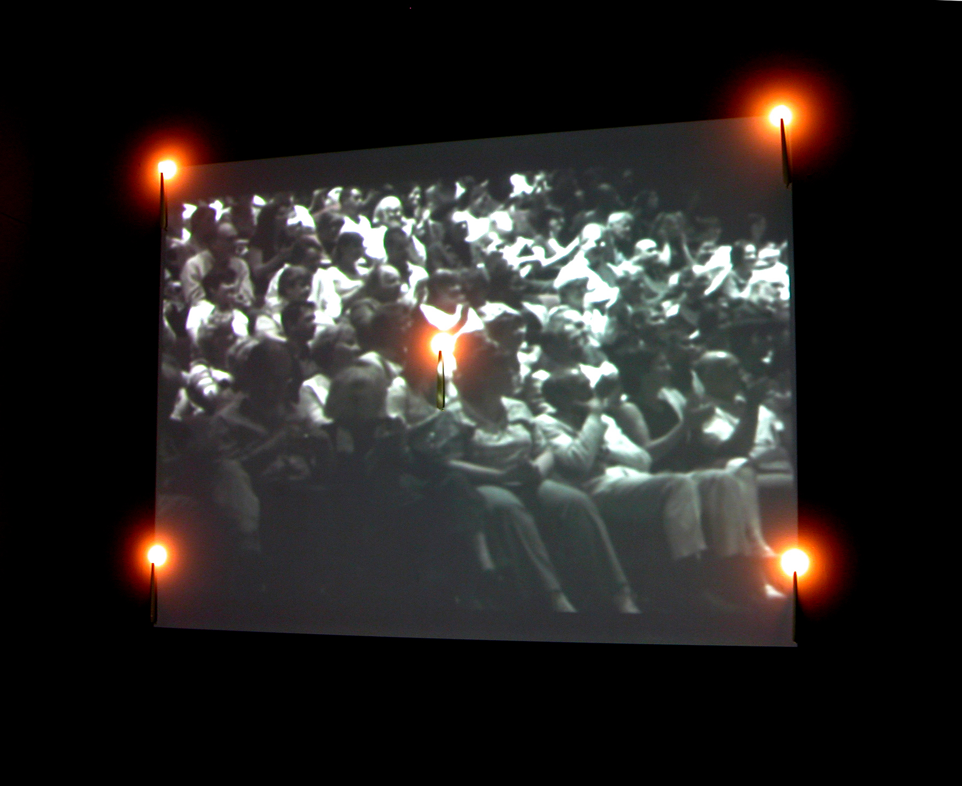
During a talk at the Writer’s Festival that took place in June 2006 in the Project Art Space, Dublin, Living Lenses were hypnotized by the sound of the syncopated rhythm created by the audience’s applause. The repetitious clapping is a constant short-circuiting of the human bilateral symmetry, accumulating in a concert of chaotic wholeness, all in its own accord. Using footage from this event, Living Lenses have built their installation The Sound of the Two Hands Clapping.
Location: The Process Room
Media: Video, candle, glass, speaker, water, cling film.
Dimension: Varied.
Duration: Tuesday 11th July – Sunday 16th July

FIONA MCBRIDE
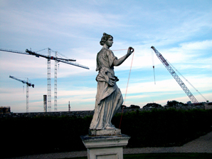
Fiona McBride is a tale about the first artist in residence at IMMA, told by Living Lenses. It is also the story of how human beings deal with the wrath of the Gods. Visitors to the piece will help build the content and context of this work by connecting their own cardio-pulses with that of Fiona’s, via an electronic circuit.
Location: The Formal Gardens
Media: Garden statue, electronic circuits, your cardio-pulses.
Dimensions: H320cm x W90cm x D110cm
Duration: Tuesday 11th July – Sunday 23rd July

SELECTIVE MEMORY GAME
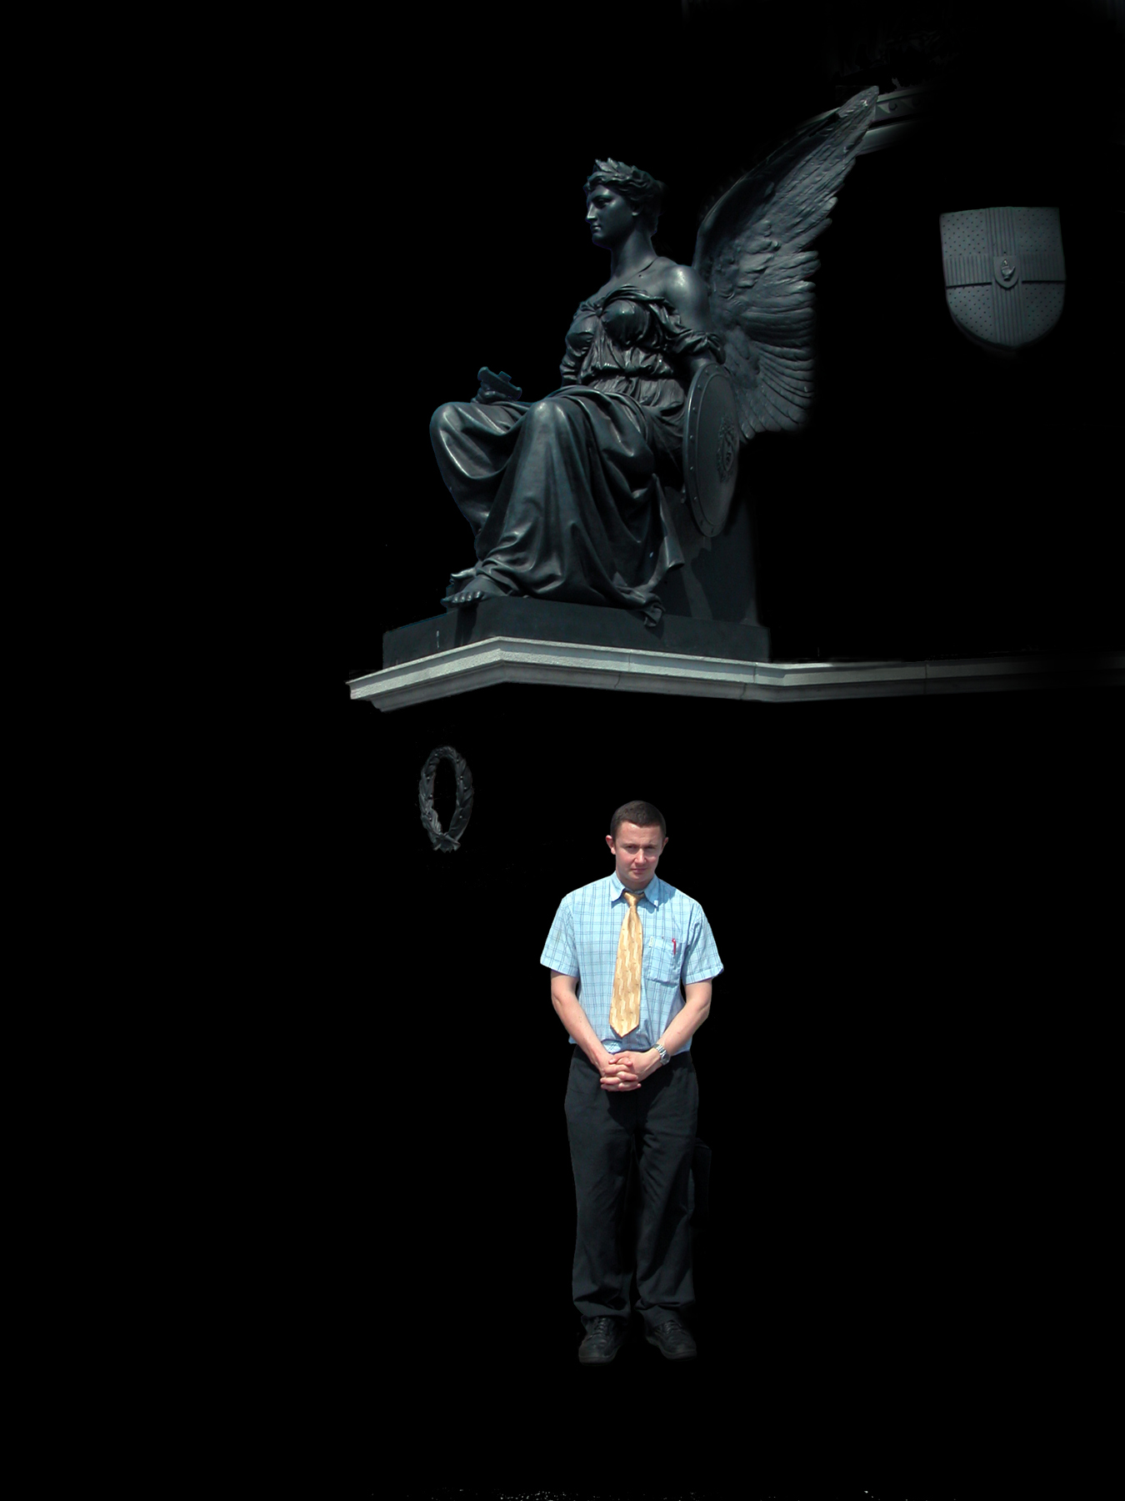
The Selective Memory Game is a photographic project of Dubliners going about their businesses around town. Each image comes in a pair, where one is an edited version of the original image. The game is structured to allow, the players/visitors to the process room, personal operating paradigms to determine which images will end up being displayed at any given moment.
Location: The Process Room
Media: Photographic images.
Dimensions: Varied.
Duration: Tuesday 18th July – Sunday 23rd July

DNA DONATION
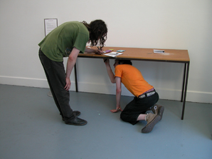
The DNA Donation project is made up entirely by the participation of visitors to IMMA. The project takes place in Living Lenses studio, studio 12. A donation is done in three simple steps. Chew a piece of gum, stick it to the underside of the donation table, and sign on the tabletop. The signature will confirm the donation of DNA to a Living Lenses artwork, and that the donor is a co-author of the artwork.
Location: Studio 12.
Media: Table, chewing gum, DNA samples.

Dimension: H82 x W180 x D60.
Duration: Tuesday 11th July – Sunday 23rd July.

Living Lenses are on residency at IMMA from May - July 2006 and are located in Studio 12 for the duration of their residency.

For more information on any aspect of the Artists’ Residency Programme please contact Janice Hough, Artists’ Residency Programme Co-ordinator, Tel + 353-1-612 9905 or Email janice.hough@imma.ie, Website www.imma.ie

