Juliette Blightman
the day grew darker still
showing at the Irish Museum of Modern Art

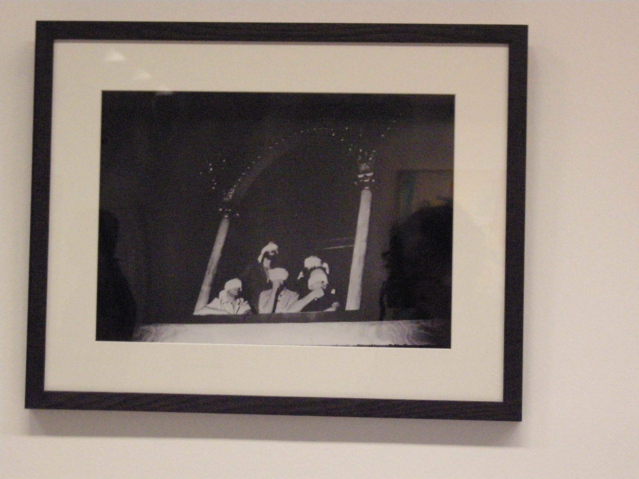
Lecture / Event
18.05.10
The Lecture Room at 5pm
Duration: 20 minutes
No Booking Required

Exhibition
18.05.10 – 30.05.10
The Process Room, West Wing First Floor Galleries
18.05.10 – 30.05.10

Juliette Blightman uses film to capture moments in which time seems to stand still. Her films are not staged, each scene existing regardless of her camera filming or not. Using film and slide works, and direct yet subtle interventions in the gallery space, Blightman's work frames and enacts a certain kind of unadorned reality.

Within a structure marked out by deliberately simple gestures, the marking of time gradually gives way to a sense of epiphany. In a series of 16mm films made from 2007, Blightman uses the basic parameters of her chosen medium to emphasise the reality of what is in front of her camera. Each work consists of a single shot, the length of which is dictated by the standard three-minute duration of the film stock. Three o’clock is her favourite hour for filming, a time when she feels that ‘nothing happens’. Time is lost, folded for ever inside the medium that was designed to preserve it, in the same way that the past saturates objects that appear to be frozen but are decaying imperceptibly before our eyes.

Selected projects include as a period in which nothing happened, The Chips are Down, Whitechapel Project Space, London, 2007; Satellites, Tanya Bonakdar, New York, 2006, and The Glass Bead Game, Vilma Gold Project Space, Berlin, 2006. Further information on Blightman’s practice can be found at http://www.frieze.com/issue/article/juliette_blightman.

THE PROCESS ROOM FACILITATES ACCESS TO THE ONGOING PRACTICE OF ARTISTS CURRENTLY RESIDENT AT IMMA. THIS RESIDENCY PROGRAMME IS LOCATED IN THE STUDIOS ADJACENT TO THE MAIN MUSEUM BUILDING WHERE SEVERAL STUDIOS ARE ALLOCATED TO BOTH NATIONAL AND INTERNATIONAL ARTISTS. THE PROCESS ROOM IS USED ON A ROTATING BASIS BY THE ARTISTS ON THE ARP.

For more information about the Artists’ Residency Programme please contact Janice Hough, ARP Co-ordinator, Tel + 353.1.612 9905 or janice.hough@imma.ie Website www.imma.ie

The atmospheric conditions and phenomena which constitute "The Weather" are of surpassing interest. Now, we rejoice in the genial air and warm rains of spring, which clothe the earth with verdure; in the alternating heat and showers of summer, which insure the bountiful harvest; in the milder, ripening sunshine of autumn; or the mantle of snow and the invigorating air of a moderate winter's-day. Now, again, we suffer from drenching rains and devastating floods, or excessive and debilitating heat and parching drought, or sudden and unseasonable frost, or extreme cold. And now, death and destruction come upon us or our property, at any season, in the gale, the hurricane, or the tornado; or a succession of sudden or peculiar changes blight our expected crops, and plant in our systems the seeds of epidemic disease and death. These, and other normal conditions, and varied changes, and violent extremes, potent for good or evil, are continually alternating above and around us. They affect our health and personal comfort, and, through those with whom we are connected, our social and domestic enjoyments. They influence our business prosperity directly, or indirectly, through our near or remote dependence upon others. They limit our pleasures and amusements - they control the realities of to-day, and the anticipations of to-morrow. None can prudently disregard them; few can withhold from them a constant attention. Scientific men, and others, devote to them daily hours of careful observations and registration. Devout Christians regard them as the special agencies of an over-ruling Providence. The prudent, fear their sudden or silent mysterious changes; the timid, their awful manifestations of power; and they are, to each and all of us, ever present objects of unfailing interest.

The Philosophy of the Weather: And a guide to its changes
Thomas Belden Butler
1856

