Artists’ Residency Programme (ARP),

The Process Room

West Wing, First Floor Galleries, Irish Museum of Modern Art

The function of the Process Room is to reveal the processes in the creation, exhibition and consideration of contemporary art, which are often hidden from the public. The Process Room facilitates access to the ongoing practice of artists currently in residence at IMMA. This residency programme is located in the studios adjacent to the main Museum building. Several studios are allocated to both national and international artists and the Process Room is used on a rotating basis to display a taste of what is ongoing in the studio environments. Further information on ARP can be found at www.imma.ie.

Jan Christensen (Norway) – Studio 11
Tuesday 1st – Sunday 13th November 2005

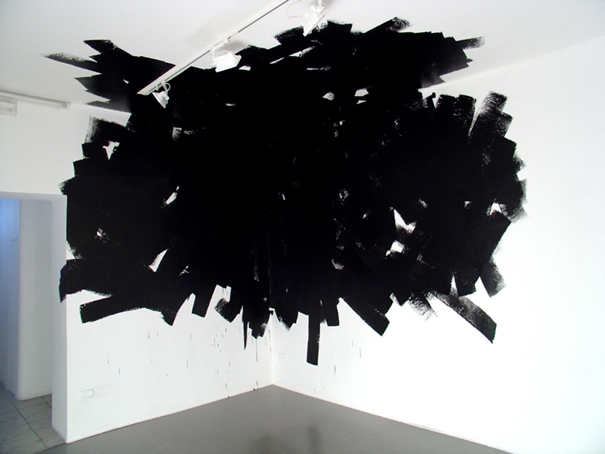
Jan Christensen’s work consists mostly of big installations for exhibitions and site-specific projects. Most of his work is wall drawing and painting. An installation is carefully planned out and sketched with a computer before it is meticulously carried out on location. Christensen uses a wide scope of visual references in his work from architectural plans to iconic imagery from pop culture
Black-corner-Naples-2005

“For my project in the process room I will be installing a wall painting. The work is an experiment for a large commission that I have proposed for the entrance hall of a hotel in Gothenburg, Sweden. I would like to make a work that could have the lasting effect of a decorative backdrop for the hotel, rather than producing a complicated figurative composition with a complex narrative and literal references. Of course, the colourful pattern of stripes might produce associations ranging from Bridget Riley (with a psychedelic twist,) and Jim Lambie, to Paul Smith’s patterns for clothes and Iittala ceramics.

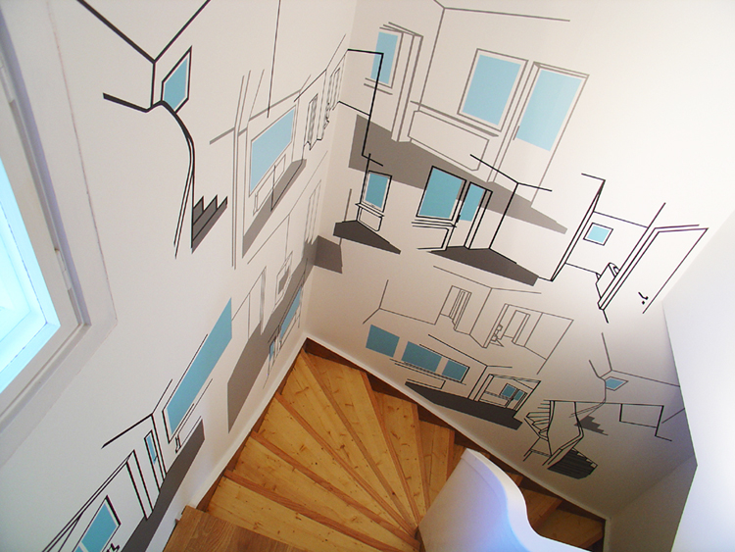
I have produced a range of work dealing with issues such as appropriation, site-specificity and architecture, questioning notions of authenticity and discussing the objecthood of art. Parallel to the critical practice I have been experimenting with painting and formal issues, often involving large-scale installation work for the respective exhibition spaces.”
Jan Christensen, Oct 2005
Site-spec-Oslo-2005

For Further information on Jan Christensen please go to www.janchristensen.org

